**[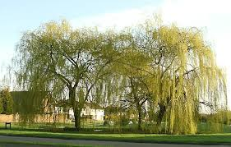](http://images.google.com/imgres?imgurl=http://www.icteachers.co.uk/photos/photos/willows.jpg&imgrefurl=http://www.icteachers.co.uk/photos/trees.htm&usg=__5X3NyW7mwexVzbL1h5wtj1AGu08=&h=446&w=700&sz=101&hl=en&start=2&sig2=PBoWIozDIpNh7TI8OktHRg&tbnid=nazYpTYFs0fBSM:&tbnh=89&tbnw=140&prev=/images?q=willows&gbv=2&hl=en&ei=Vk0ISvLBHt-DlAfJsJjkBA)MCj02791580000[1]MCj03313760000[1]The Lady of Shalott**

On either side the river lie 1  
Long fields of barley and of rye,   
That clothe the wold and meet the sky;   
And through the field the road run by   
To many-tower'd Camelot; 5  
And up and down the people go,   
Gazing where the lilies blow   
Round an island there below,   
The island of Shalott.

Describe the mood of the opening of the poem (lines 1-9). Underline words in the poem that suggest that mood.

[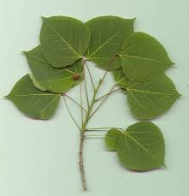](http://images.google.com/imgres?imgurl=http://z.about.com/d/forestry/1/0/t/Qaspen.jpg&imgrefurl=http://forestry.about.com/od/hardwoods/ss/aspen_2.htm&usg=__Rl1_jOckqw9zeTkZdOblPXSN8GE=&h=460&w=444&sz=23&hl=en&start=8&sig2=ylsTff8ydrrAyPv-k0WPmA&tbnid=2SbcoFEseMotYM:&tbnh=128&tbnw=124&prev=/images?q=aspen+tree&gbv=2&hl=en&sa=G&ei=ik0ISqnmN-aClAesgozkBA)Willows whiten, aspens quiver, 10  
Little breezes dusk and shiver   
Through the wave that runs for ever   
By the island in the river   
Flowing down to Camelot.   
Four grey walls, and four grey towers, 15  
Overlook a space of flowers,   
And the silent isle imbowers   
The Lady of Shalott.

2. Circle the verbs that describe things moving in lines 10-15. Do these verbs foreshadow good or bad?

3. What associations do grey walls and grey towers evoke in your mind?

[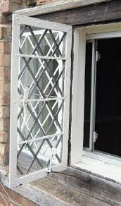](http://images.google.com/imgres?imgurl=http://www.buildingconservation.com/articles/windowfurn/fig3.jpg&imgrefurl=http://www.buildingconservation.com/articles/windowfurn/windowfurniture.htm&usg=__8Rm0Rpu45cskfeBv53_CzSp-tDk=&h=511&w=302&sz=40&hl=en&start=103&sig2=A-XFswgBxh7kwJGLgSlqFQ&tbnid=gulYpEPAqI4wAM:&tbnh=131&tbnw=77&prev=/images?q=casement+antique&gbv=2&ndsp=20&hl=en&sa=N&start=100&ei=TVIISsqsF8SVlAfDnYzjBg)By the margin, willow veil'd,  
Slide the heavy barges trail'd 20  
By slow horses; and unhail'd   
The shallop flitteth silken-sail'd  
Skimming down to Camelot:   
But who hath seen her wave her hand?   
Or at the casement seen her stand? 25  
Or is she known in all the land,   
The Lady of Shalott?

4. What is going on on the river (20-23)? What mood do these images evoke? (

Only reapers, reaping early,   
In among the bearded barley   
Hear a song that echoes cheerly 30  
From the river winding clearly;   
Down to tower'd Camelot;   
And by the moon the reaper weary,   
Piling sheaves in uplands airy,   
Listening, whispers, " 'Tis the fairy 31  
The Lady of Shalott."

5. What associations does the word “reaper” have? If you don’t know, ask a friend. You know, because we talked about when reading “The Ancient Mariner”!

[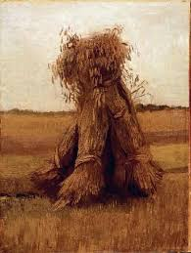](http://images.google.com/imgres?imgurl=http://static.howstuffworks.com/gif/early-paintings-by-vincent-van-gogh-14.jpg&imgrefurl=http://entertainment.howstuffworks.com/early-paintings-by-vincent-van-gogh13.htm&usg=__rBPfuKiXfbvfwFjd-djed9b9aQc=&h=531&w=400&sz=30&hl=en&start=4&sig2=RbrRH16tVc-ulEph3IsSjA&tbnid=fyHyZumqbj0L0M:&tbnh=132&tbnw=99&prev=/images?q=sheaves&gbv=2&hl=en&ei=OU4ISpm8BqLflQfyn9imBg)There she weaves by night and day   
A magic web with colours gay.   
She has heard a whisper say, 35  
A curse is on her if she stay   
To look down to Camelot.   
She knows not what the curse may be,   
And so she weaveth steadily,   
And little other care hath she, 40  
The Lady of Shalott.

7. The lady weaves images of what she sees in her mirror- she’s not allowed to look outside at all. What would be a modern day equivalent to that magic mirror?

6. What‘s worse to you personally, knowing what your punishment will be if you do what’s forbidden, or a vague general curse? Explain.

And moving through a mirror clear   
That hangs before her all the year,   
Shadows of the world appear.   
There she sees the highway near 45  
Winding down to Camelot;   
There the river eddy whirls,   
*And there the surly village churls,   
And the red cloaks of market girls   
Pass onward from Shalott. 50

[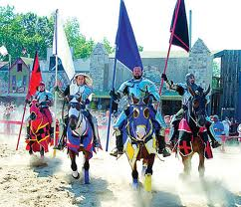](http://images.google.com/imgres?imgurl=http://www.candgnews.com/Homepage-Articles/2007/8-22-07/images/TL-RenFest3.jpg&imgrefurl=http://www.candgnews.com/Homepage-Articles/2007/8-22-07/XF-RENFEST.asp&usg=___69sxAXWFUp6VAkzbcv4KOIYQoA=&h=343&w=400&sz=112&hl=en&start=5&sig2=dkwAYDQYwS7XFVaj4GMBiw&tbnid=-oEGQH0HJHWksM:&tbnh=106&tbnw=124&prev=/images?q=knights+come+riding&gbv=2&hl=en&ei=q04IStKgOo2FlAeWn5ScAg)[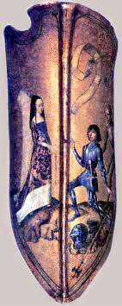](http://images.google.com/imgres?imgurl=http://www.chivalrynow.net/images/pictures/shield.jpg&imgrefurl=http://www.chivalrynow.net/images/pictures/shield.htm&usg=__iXDge3welxrsX5XawnhF6vTolcQ=&h=537&w=215&sz=27&hl=en&start=10&sig2=FcLYqS4fgo0QEj-LkK1FZg&tbnid=dpwT9C4h5lSsHM:&tbnh=132&tbnw=53&prev=/images?q=Sir+Lancelot's+shield&gbv=2&hl=en&ei=PU8ISrT7DoiclQf376nwBA)Sometimes a troop of damsels glad,   
An abbot on an ambling pad,   
Sometimes a curly shepherd lad,   
Or long-hair'd page in crimson clad   
Goes by to tower'd Camelot; 55  
And sometimes through the mirror blue   
The knights come riding two and two.   
She hath no loyal Knight and true,

8. Underline the people who pass by the lady’s tower between line 48-66.

Suggest a theory as to why THOSE people, in THAT order were chosen by Tennyson.

The Lady of Shalott.

[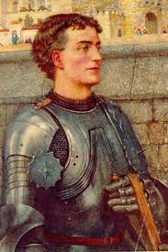](http://images.google.com/imgres?imgurl=http://www.internationalhero.co.uk/l/lancelot.jpg&imgrefurl=http://www.internationalhero.co.uk/l/lancelot.htm&usg=__JpEzRwx_1DsnDuZSghLlNAmk8c0=&h=494&w=330&sz=56&hl=en&start=34&sig2=uyqdhP685FKJrMQHPdJ2lQ&tbnid=J63kAP4e95TLJM:&tbnh=130&tbnw=87&prev=/images?q=Sir+Lancelot&gbv=2&ndsp=20&hl=en&sa=N&start=20&ei=_04ISvfFJ6GElAfH0YTkBA)But in her web she still delights 60  
To weave the mirror's magic sights,   
For often through the silent nights   
A funeral, with plumes and lights   
And music, went to Camelot;   
Or when the Moon was overhead, 65  
Came two young lovers lately wed.  
"I am half sick of shadows," said   
The Lady of Shalott.

9. What finally `breaks’ the lady, causing her to cry out “I am …”?

A bow-shot from her bower-eaves,   
He rode between the barley sheaves, 70  
The sun came dazzling thro' the leaves,   
And flamed upon the brazen greaves   
Of bold Sir Lancelot.   
A red-cross knight for ever kneel'd   
To a lady in his shield, 75  
That sparkled on the yellow field,   
Beside remote Shalott.

10. Underline all the words and phrases in the next 3 stanzas that evoke images of sparkling, light, glittering stuff. (“The gemmy….Sir Lancelot”)

10. Who causes the lady to forget the rules and turn to look outside??

The gemmy bridle glitter'd free,   
Like to some branch of stars we see   
Hung in the golden Galaxy. 80  
The bridle bells rang merrily   
As he rode down to Camelot:   
And from his blazon'd baldric slung   
A mighty silver bugle hung,   
And as he rode his armor rung 85  
Beside remote Shalott.

11. The Lady **knows** that something will happen to her if she looks out a window. So obviously, leaving her tower is going to have consequences. Yet, she drops everything, looks out the window, and then leaves her tower. Why? What is it about Lancelot (no other knight or person had that effect on her) that made her risk everything? (For Ms. Simon, it would be Johnny Depp… for me, it’s that grin and sparkle in his eyes)

[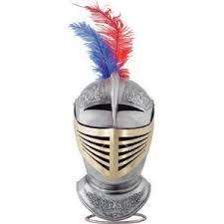](http://images.google.com/imgres?imgurl=http://www.aurorahistoryboutique.com/products/CA00011_L.jpg&imgrefurl=http://www.aurorahistoryboutique.com/ahb_medievalArmor.htm&usg=__LF5fIFq3MhJZcOaPJ63zZxGW8i8=&h=300&w=300&sz=15&hl=en&start=3&sig2=Jo6jY528zoBtZaRz0Tfwsw&tbnid=t5iPcV0e36K7VM:&tbnh=116&tbnw=116&prev=/images?q=helmet+feather&gbv=2&hl=en&ei=fk8IStH1DcjMlQeXxfXnBg)All in the blue unclouded weather   
Thick-jewell'd shone the saddle-leather,   
The helmet and the helmet-feather   
Burn'd like one burning flame together, 90  
As he rode down to Camelot.   
As often thro' the purple night,   
Below the starry clusters bright,   
Some bearded meteor, burning bright,   
Moves over still Shalott. 95

His broad clear brow in sunlight glow'd;   
On burnish'd hooves his war-horse trode;   
From underneath his helmet flow'd   
His coal-black curls as on he rode,   
As he rode down to Camelot. 100  
From the bank and from the river   
He flashed into the crystal mirror,   
"Tirra lirra," by the river   
Sang Sir Lancelot.

[](http://images.google.com/imgres?imgurl=http://www.teachenglishinasia.net/files/u2/white_water_lily_pad.jpg&imgrefurl=http://www.teachenglishinasia.net/asiablog/asian-water-lilies-and-lotus-flowers&usg=__K536P8hdz1h_mb5yxQOZJ8fq24M=&h=364&w=500&sz=40&hl=en&start=1&sig2=8KUPBNLWMCvtjNuIUGkD4Q&tbnid=WJdRndVabeawtM:&tbnh=95&tbnw=130&prev=/images?q=water+lily&gbv=2&hl=en&ei=p08ISqfJFcTMlQes3vXnBg)She left the web, she left the loom, 105  
She made three paces through the room,   
She saw the water-lily bloom,   
She saw the helmet and the plume,   
She look'd down to Camelot.   
Out flew the web and floated wide; 110  
The mirror crack'd from side to side;   
"The curse is come upon me," cried   
The Lady of Shalott.

In the stormy east-wind straining,   
The pale yellow woods were waning, 115  
The broad stream in his banks complaining.   
Heavily the low sky raining   
Over tower'd Camelot;   
Down she came and found a boat   
Beneath a willow left afloat, 120  
And around about the prow she wrote   
**The Lady of Shalott.**

12. How does the weather and nature change as the lady leaves her tower (114-120)? (pathetic fallacy)

13. What do these changes foreshadow?

[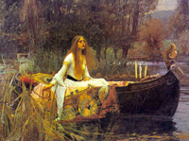](http://charon.sfsu.edu/TENNYSON/images/shallot.jpg)And down the river's dim expanse   
Like some bold seer in a trance,   
Seeing all his own mischance -- 125  
With a glassy countenance   
Did she look to Camelot.   
And at the closing of the day   
She loosed the chain, and down she lay;   
The broad stream bore her far away, 130  
The Lady of Shalott.

Lying, robed in snowy white

That loosely flew to left and right --   
The leaves upon her falling light --   
Thro' the noises of the night, 135  
She floated down to Camelot:   
And as the boat-head wound along   
The willowy hills and fields among,   
They heard her singing her last song,   
The Lady of Shalott.

14. What is the lady doing as she drifts toward Camelot?

15. What is the rhyme pattern of this poem? Why do you think I ask this question HERE? How is the effect of that rhyme pattern so evident and important in lines 140- ? Read it out loud a few times… What do you hear??

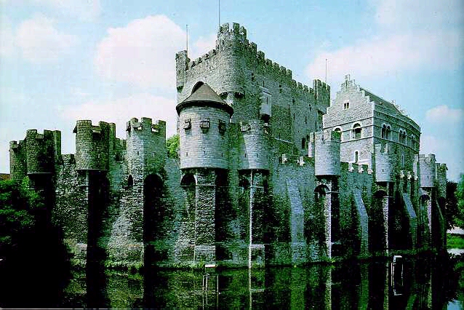Heard a carol, mournful, holy, 140  
Chanted loudly, chanted lowly,   
Till her blood was frozen slowly,   
And her eyes were darkened wholly,   
Turn'd to tower'd Camelot.   
For ere she reach'd upon the tide 145  
The first house by the water-side,   
Singing in her song she died,   
The Lady of Shalott.

Under tower and balcony,   
By garden-wall and gallery, 150  
A gleaming shape she floated by,   
Dead-pale between the houses high,   
Silent into Camelot.   
Out upon the wharfs they came,   
Knight and Burgher, Lord and Dame, 155  
And around the prow they read her name,   
**The Lady of Shalott**.

16. What happens to her? Why?

17. How is Lancelot’s reaction to the lady different from his peers’ reactions?

Who is this? And what is here?   
And in the lighted palace near   
Died the sound of royal cheer; 160  
And they crossed themselves for fear,   
All the Knights at Camelot;   
But Lancelot mused a little space   
He said, "She has a lovely face;   
God in his mercy lend her grace, 165  
The Lady of Shalott."

18. Is Lancelot just amazed by her beauty, or could he, would he, have been interested in her? Justify your answer, and consider the lifestyles they’ve led, their values.

*Life. A long and safe one, or a short and exhilarating one?* Of the texts we’ve read this year, which authors do you think are basically voting for Long and Safe, and which are voting for Short and Exhilarating?

|  |  |
| --- | --- |
| Writer: | Long/safe or short and exhilarating? |
| Of Beowulf |  |
| Sir Gawain |  |
|  |  |
|  |  |
|  |  |
|  |  |
|  |  |
|  |  |
|  |  |
|  |  |

☺ Another poem to read to your kids one day. It’s more fun to read out loud than to read silently!